RESEARCH PERMIT LETTER
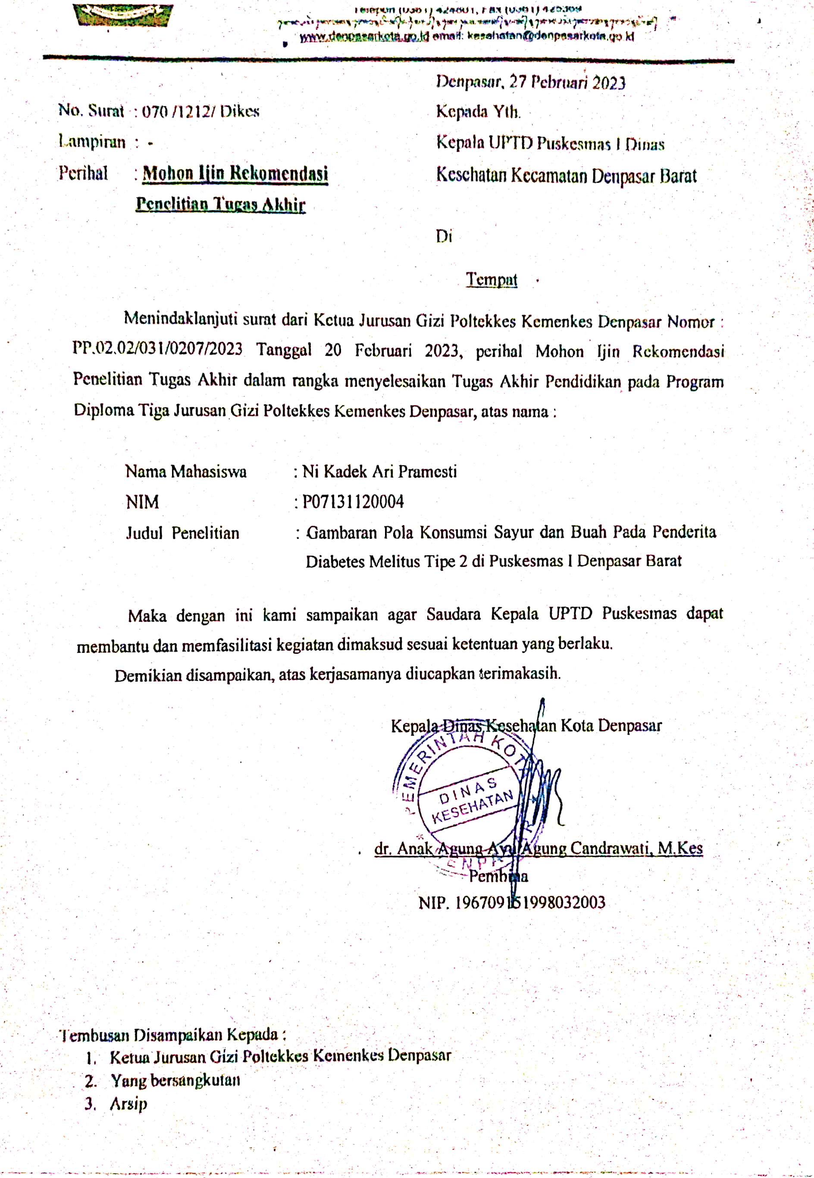

SAMPLE IDENTITY QUESTIONNAIRE
- Sample Identity
1. | Sample Code
2. | Sample Name
3. | Date and Place of Birth
4. | Age
5. | Home Address
6. | Gender | Male/Female*
7. | Phone Number
8. | Last Education
9. | Job
10. | History of Complications | Any/No*
11. | Type of Complication
*Cross the unnecessary ones
- Anthropometric data
No | Measurement | Result
1. | Weight | Kg
2. | Height | Cm

- Blood Sugar Level
Type of Test | Blood Sugar Level | Test Date
Random Blood Sugar Test
- Food Restrictions
- ………………………………………
- ………………………………………

Denpasar, 2023

Enumerator

SEMI QUANTITATIVE FOOD FREQUENTY QUISTIONNAIRE (SQ-FFQ) FORM
Sample Code :
Sample Name :
No | Food | Standard Size | Frequency |  |  |  |  |  |  |  | Portion Size |  |  | Daily Consumption
No | Food | Standard Size | Never | 1-3/ bln | 1x/ mg | 2-3/ mg | 4-6/ mg | 1x/ hari | 2-3x/ hari | 4-5x/ hari | S | M | L | Daily Consumption
Vegetables
1 | Spinach (20 g) | 2 tbsp
2 | Water Spinach (30 g) | 2 tbsp
3 | Mustard Green (20 g) | 2 tbsp
4 | Carrot (20 g) | 2 tbsp
5 | Tomato (15 g) | 1/4 piece
6 | Snaps bean (20 g) | 2 tbsp
7 | Mushroom (15 g) | 1 1/2 tbsp
8 | Long Beans (20 g) | 2 tbsp
9 | Cabbage (10 g) | 1 tbsp
10 | Chayote ( 20 g) | 2 tbsp
11 | Bean Sprouts ( 15 g) | 1 tbsp
12 | Cucumber ( 20 g) | 2 slice
13 | Pumpkin ( 20 g) | 2 tbsp
14 | Broccoli (20 g) | 2 tbsp
15 | Cauliflower ( 20 g) | 2 tbsp
16 | Moringa (20 g) | 2 tbsp
17 | Bitter Melon (50 g) | 5 tbsp
Total
Fruits
1 | Water Melon (50 g) | 1/2 medium slice
2 | Papaya (50 g) | 1/2 medium slice
3 | Banana ( 50 g) | 1/2 medium slice
4 | Orange ( 50 g) | 1/2 medium slice
5 | Apple (50 g) | 1/4 medium slice
6 | Melon (50 g) | 1/2 medium slice
7 | Snakefruit (35 g) | 1 medium fruit
8 | Avocado (30 g) | 1/4 large fruit
9 | Guava ( 25 g) | 1/2 medium fruit
10 | Sapodilla ( 50 g) | 1 medium fruit
11 | Rambutan (20 g) | 2 pieces
12 | Jicama (50 g) | 1/2 medium fruit
13 | Grape ( 25 g) | 5 pieces
14 | Strawberry ( 30 g) | 5 pieces
15 | Mango ( 50 g) | 1/2 medium slice
16 | Noni Fruit (50 g) | 1 medium fruit
17 | Sugar apple (50 g) | 1 medium fruit
18 | Soursop (50 g) | 1/2 medium fruit
Total

ACTIVITY DOCUMENTATION

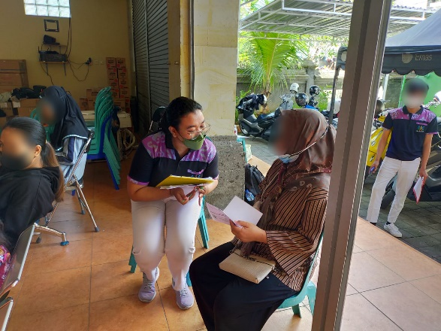 | 