Research Permit Letter
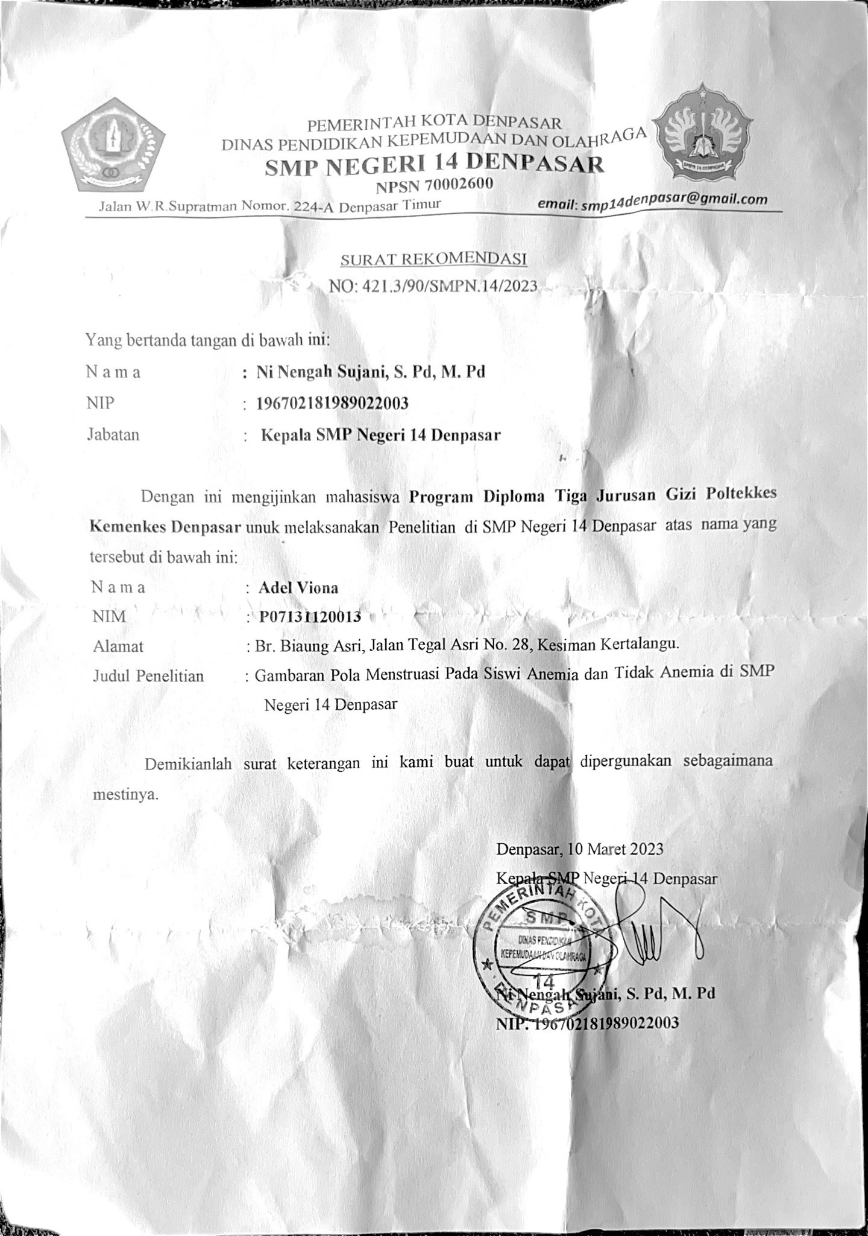

Ethical Approval
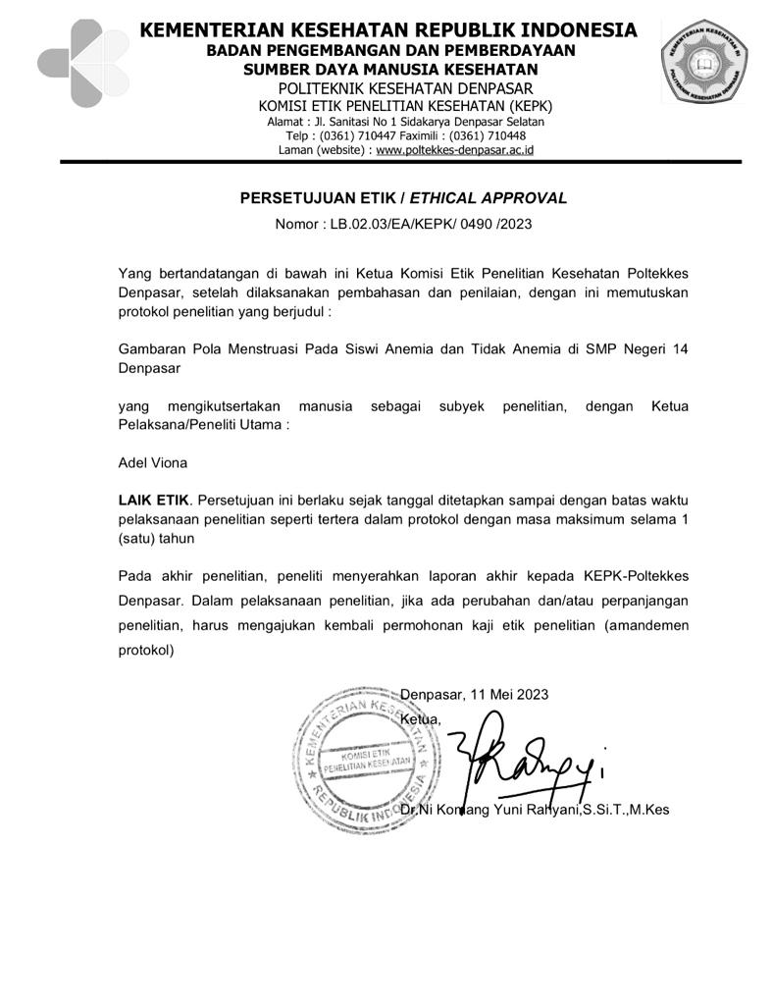

Questionnaire
- Sample Identity
No. | Sample Identity
1. | Sample Code
2. | Sample Name
3. | Date of Birth
4. | Age (Year)
5. | Address
6. | Mobile No.
7. | Class | VII VIII IX
Attachment 3. Questionnaire
- Anthropometric Data
- Weight : kg
- Height : cm

- Biophysical Data
- Do young women feel weak?
- Yes
- No
- Do young women feel lethargic?
- Yes
- No
- Do young women feel tired?
- Yes
- No
- During the past week, you often feel dizzy
- Yes
- No
- Do teenage girls often experience crossed-eyes?
- Yes
- No
- Biochemical Data
- Hemoglobin Level : g/dL
- Anemia Status :

- Demographic Data
Instructions for filling in: fill in the data below correctly and correctly. Put a check list mark (√) in the available selection box, or by filling in the dots according to your current situation and condition.
1 | Age of First Menarche | : | Under 12 years old  12 - 13 years  Above 13 years old
2 | Smoking History | : | Available  No
3 | Gynecologic Diseases (Reproductive Diseases) | : | None (please specify)  No
4 | Taking hormonal drugs | : | None (please specify)  No
5 | Other diseases | :

- Menstrual Pattern

- How is your period every month?
- 1 time every month.
- 2 times in 1 month.
- Sometimes 1 month of menstruation, the next month no menstruation.

- The menstrual cycle is the distance between the date you had your last period and the start of your next period. How many days does your menstrual cycle last?
- 21-35 days
- < 21 days
- > 35 days
- > 3 months
- If you don't know about your menstrual cycle, what was the first day of your period 2 months ago?
- .............................................................
- .............................................................
- How many days does your period last?
- 4-6 days
- < 4 days
- > 6 days
- How many sanitary pads do you use in a day?
- Do you experience pain during menstruation?
  - Yes
  - No

Documentation
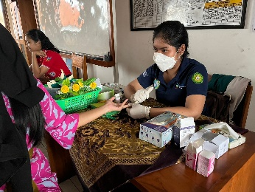 | 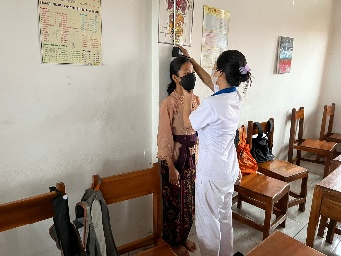 | 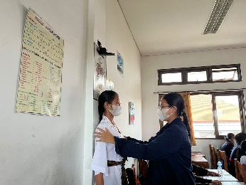
Blood sampling | Height measurement | Height measurement
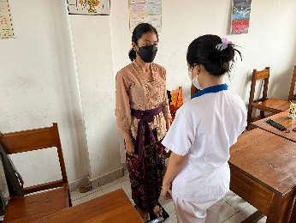 | 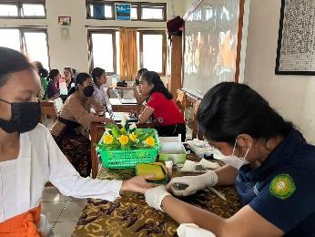 | 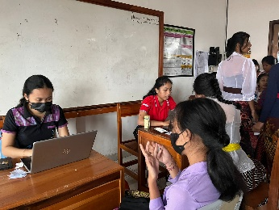
Weight weighing | Blood sampling | Interview

