Research Permit Letter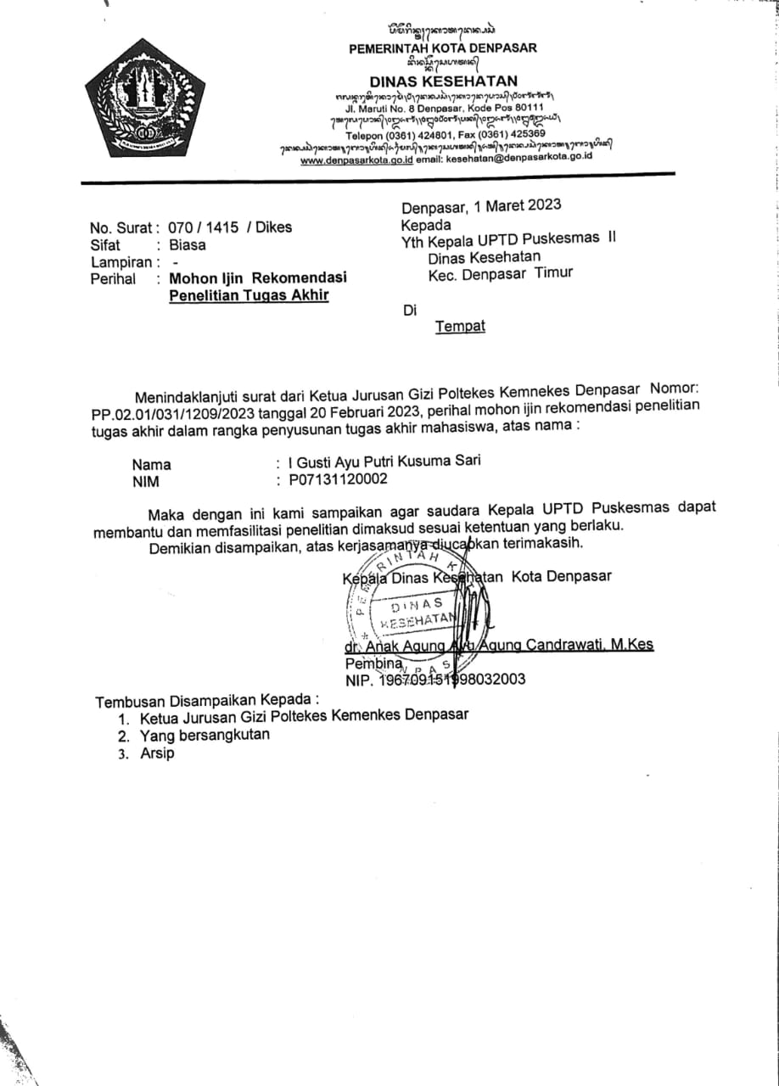

Ethical Approval
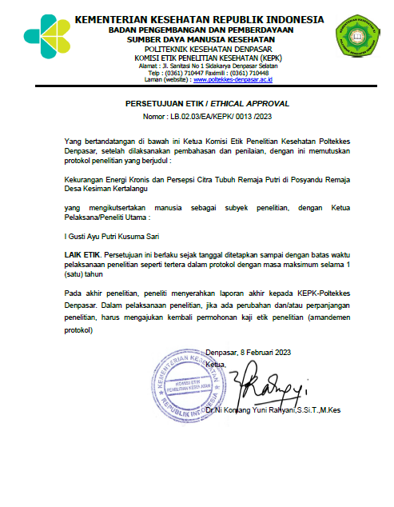

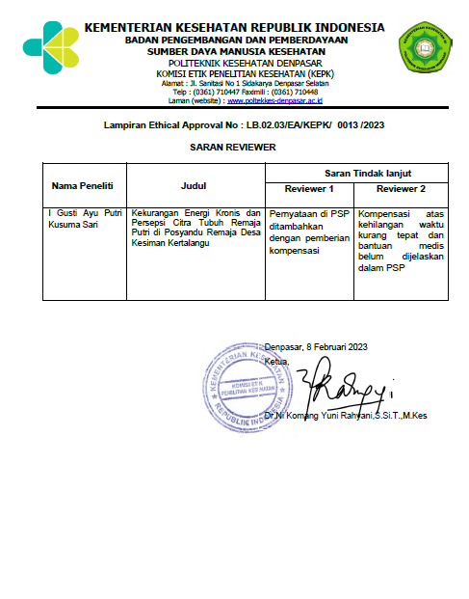
Semi Quantitative Food Frequency Questionnaire (SQ-FFQ) Form
Sample Identity

Sample Code |  | :
Date of birth |  | :
No | Food Material | Standard Size | Frequency |  |  |  | Portion Size |  |  | Daily Consumption
No | Food Material | Standard Size | Never | Monthly | Weekly | Daily | S (0,5) | M  (1) | B (1,5) | Daily Consumption
Starchy
1 | Rice (200 g) | 1 plate
2 | White bread (25 g) | 1 slice
3 | Corn (20 g) | 2 tablespoons
4 | Potato (50 g) | ½ medium fruit
5 | Sweet Potato ( 50 g) | ½ medium fruit
6 | Noodles (200 g) | 1 pack
Green Vegetable
7 | Water Spinach (30 g) | 2 tablespoons
8 | Mustard Greens (20 g) | 2 tablespoons
9 | Snaps (20 g) | 2 tablespoons
10 | Cassava leaves (30 g) | 2 tablespoons

No | Food Material | Standard Size | Frequency |  |  |  |  | Portion Size |  |  |  | Daily Consumption
No | Food Material | Standard Size | Never | Monthly | Weekly | Daily |  | S (0,5) |  | M  (1) | B (1,5) | Daily Consumption
Fruits and Vegetables Sources of Vitamin A
11 | Spinach (20 g) | 2 tablespoons
12 | Carrot (20 g) | 2 tablespoons
13 | Tomato (15 g) | 1/4 piece
14 | Manggo ( 50 g) | ½ medium slice
15 | Papaya (50 g) | ½ medium slice
Other Fruits and Vegetables
16 | Mushroom (15 g) | 1 ½ tablespoons
17 | Long beans ( 20 g) | 2 tablespoons
18 | Cabbage (10 g) | 1 tablespoons
19 | Chayote ( 20 g) | 2 tablespoons
20 | Watermelon (50 g) | ½ medium slice
21 | Banana ( 50 g) | ½ medium slice
22 | Sweet Orange ( 50 g) | ½ medium slice
23 | Appel (50 g) | ½ medium slice
24 | Melon (50 g) | ½ medium slice
Innards
25 | Liver (30 g) | 1 medium fruit
26 | Gizzard (30 g) | 1 medium fruit
27 | Lungs (30 g) | 1 medium fruit
28 | Intestines (50 g) | 1 big piece

No | Food Material | Standard Size | Frequency |  |  |  | Portion Size |  |  | Daily Consumption
No | Food Material | Standard Size | Never | Monthly | Weekly | Daily | S (0,5) | M  (1) | B (1,5) | Daily Consumption
Meat and Fish
29 | Chicken Meat (40 g) | 1 medium slice
30 | Pork ( 25 g) | ½ medium slice
31 | Fish (20 g) | ½ medium slice
32 | Shrimp ( 20 g) | 3 medium tail
Eggs
33 | Chicken Eggs ( 55 g) | 1 eggs
34 | Duck Eggs (50 g) | 1 eggs
35 | Quail Eggs (55 g) | 5 eggs
Nuts and Grains
36 | Tofu (50 g) | ½ medium slice
37 | Tempeh ( 50 g) | 1 medium slice
38 | Mung beans (20 g) | 2 tablespoons
39 | Peanuts (15 g) | 2 tablespoons
Milk and its Processed Products
40 | Cow's milk (200 ml) | 1 cup
41 | Yoghurt (100 g) | ½ cup
42 | Cheese ( 15 g) | ½ small slice
43 | Ice Cream (25 g) | 1 scop
Total

Body Shape Questionnaire (BSQ)
Sample Identity
Sample Name :
Phone :
We want to know how you feel about your performance over the last four weeks. Please read the question and select the appropriate number by ticking it (√).
Information :
1 : Never  2 : Seldom  3 : Sometimes |  | 4 : Often  5 : Very often  6 : Always
No | Question |  | Answer Choices
No |  |  | 1 | 2 | 3 |  | 4 | 5 | 6
1 | Are you worried about your body shape and feel like you have to adjust your diet?
2 | Are you afraid of your body getting fat or getting fatter?
3 | Has feeling full ever made you feel fat? (e.g. after a large meal)
4 | Do you pay attention to other people's body shapes and feel like your body shape is not as good as other people's?
5 | Have you ever thought so much about your body shape that it disturbed your concentration (for example when watching TV, reading, chatting)?
6 | Do you feel fat when you are not dressed (for example when showering)?
7 | Do you feel more disturbed about your body shape when you are with other people?
8 | Have you ever decided not to hang out or socialize just because you felt dissatisfied with your body shape?
9 | Do you feel too fat and round?
10 | Do you think your current body shape is caused by a lack of self-control?
11 | Do you worry about your body shape and feel like you have to exercise?
12 | Have you ever intentionally vomited to feel thinner?
13 | Do you feel sad or dissatisfied when you look at your reflection? (e.g. in a mirror or in a shop window)
14 | Do you feel it's unfair if other women are slimmer than you?
15 | Do you have thoughts about getting rid of parts of your body that you feel are excessive?
16 | Has being with a slim woman ever made you feel sensitive about your body shape?
Source: (Purwanti & Marlina, 2023)

Activity Documentation
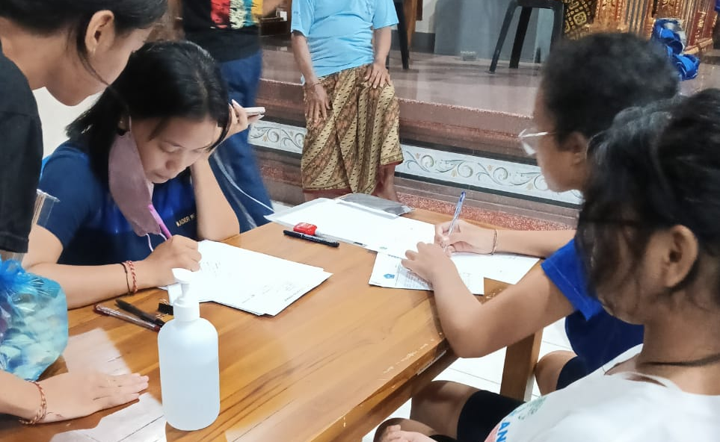 | 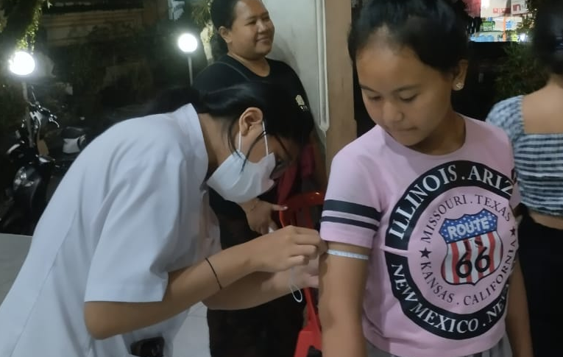
Registration | Upper Arm Circumference Measurement
 | 
Fill out the Body Shape Questionnaire | Fill out the SQ-FFQ Form
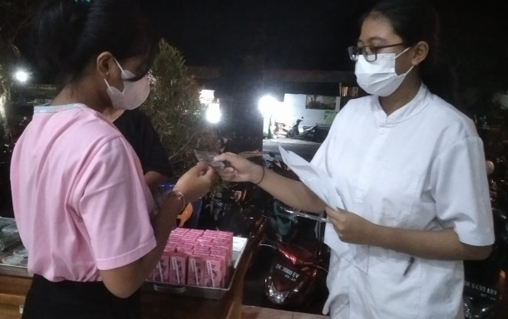 | 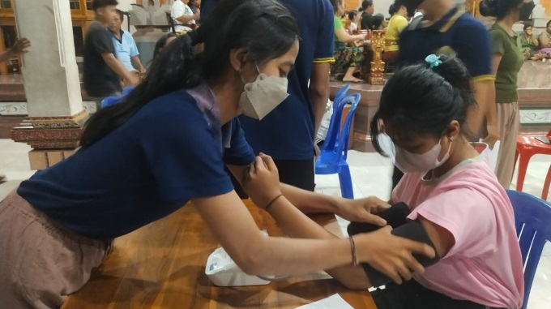
Provide Additional Food | Youth Posyandu Activities

