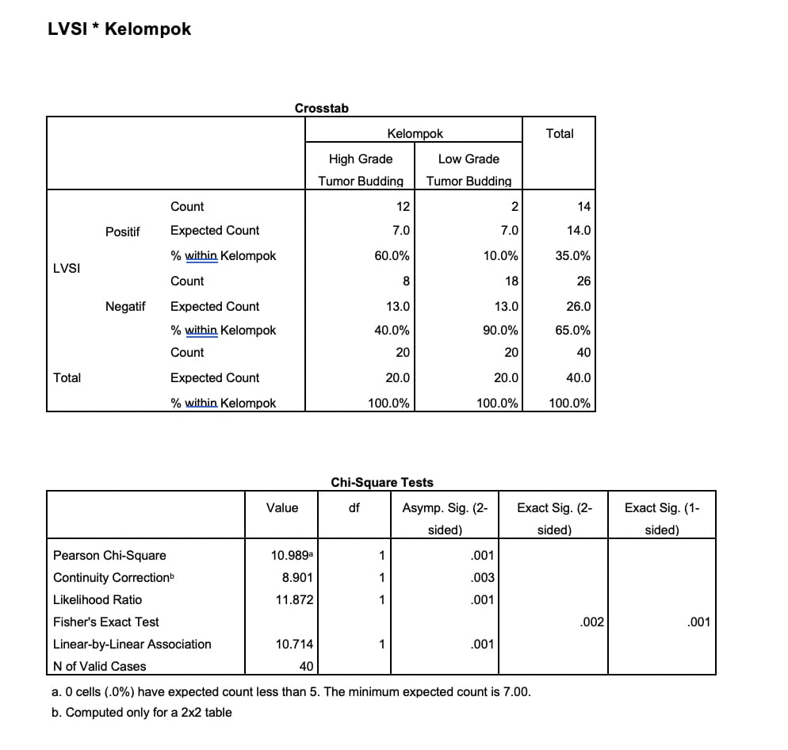

for the picture of each sample, I have upload in this link
https://drive.google.com/drive/folders/1K8GiykuBP_YarBo4DalhsTJN9UxxhbAS?usp=share_link

