HIGH MATRIX METALLOPROTEINASE 9 EXPRESSION AS A RISK FACTOR OF LYMPHOVASCULAR INVASION IN CERVICAL CARCINOMA

(The title should be no more than ten words in English, accurately describe the content, and should be centered on the page, typed in capitalized bold 16-point Times New Roman. no acronyms, each word to be capitalized with the exception of the conjunctions and prepositions)

Armerinayanti, NW*
¹Department of Anatomical Pathology, Faculty of Medicine and Health Sciences, Warmadewa University, Bali, Indonesia, 80111, 0000-0003-2499-8285
* Corresponding Author: Ni Wayan Armerinayanti
Email: armerinayantipranata@gmail.com

Article history
Posted, July 10th , 2025
Reviewed,
Received, …………….

Abstract
Background: Cervical carcinoma is an epithelial’s cervix cancer that causes the highest mortality among all female genital cancers. Its mortality influenced by metastasis to various organs, and lymphovascular invasion (LVSI) has been known to be an early stage of distant metastatic process, but it very difficult to predict early. Ability of cancer cells to penetrate the surrounding tissue then carry out LVSI occurs by cancer cells’s proteolytic enzymes. Various molecular parameters have been developed in predicting possibility of cervical carcinoma LVSI, one of the controversial proteolytic protein is matrix metalloproteinase 9 (MMP-9).
Aims: This study will prove MMP-9 as a risk factor for LVSI in cervical carcinoma.
Methods: This case control study used 40 paraffin blocks from cervical carcinoma’s patients BaliMed Denpasar Hospital. Paraffin blocks then processed immunohistochemical stain to evaluate MMP-9 expression and H&E stain to evaluate the LVSI. Data analysis was performed by Chi Square test with the SPSS 25 program.
The results: The study showed that 85,7% of cervical carcinoma with LVSI has high MMP-9 expression, with significance result compared to cervical cancer without LVSI (p=0.001).
Conclusion: The MMP-9 expression was significantly increased risk of LVSI in cervical carcinoma.

Keywords: Proteolytic enzyme, extracellular matrix, lymphovascular invasion, MMP-9

1. Introduction
Cervical carcinoma is an epithelial cancer of the cervix that causes the highest mortality among all female genital cancers in developing countries including Indonesia^{1 ,2}. The progression of cervical carcinoma is relatively fast, and is even very susceptible to causing distant metastasis. One of the triggering factors for distant metastasis in cervical carcinoma is lymphovascular invasion (LVSI). Until now, predicting the possibility of metastasis in cervical carcinoma is still an obstacle. The finding of metastasis can occur several months or years after the histopathological diagnosis of cervical carcinoma is confirmed. In reporting the histopathological results of cervical carcinoma, the diagnosis will be accompanied by the stage, grade of cancer, and findings of LVSI. LVSI is the initial process that triggers metastasis which is confirmed histopathologically if there is a picture of cancer cell emboli in the lumen of blood vessels lined with endothelial cells^{1,3}. However, until now it is very difficult to predict the possibility of intravascular invasion earlier.
Clinically, LVSI is one of the three Sedlis criteria in determining the need for adjuvant therapy such as chemoradiation after radical hysterectomy. The finding of LVSI is one of the important factors that affect the prognosis and management of cervical carcinoma. LVSI is the process by which cancer cells infiltrate the lymphatic and blood vessels, allowing the spread of cancer cells to other parts of the body^{1,4,5}. This process is very complex and involves various molecules and different signaling pathways. One group of enzymes that plays an important role in the process of invasion and metastasis is matrix metalloproteinases (MMPs), especially MMP-9. MMP-9, or gelatinase B, is a proteolytic enzyme that is able to degrade components of the extracellular matrix (ECM), such as type IV collagen and gelatin^{2,6,7,8}. Degradation of the ECM by MMP-9 facilitates the movement of cancer cells through the surrounding tissue and into the blood and lymphatic vessels⁹. In addition, MMP-9 is also involved in modulating the tumor microenvironment, which can support the growth and spread of cancer cells. Previous studies have shown that MMP-9 expression is increased in various types of cancer, including cervical carcinoma, and that the level of MMP-9 expression correlates with tumor aggressiveness and poor prognosis^{9,10,11,12,13}. Other studies have also found a positive correlation between MMP-9 and lymph node metastasis^{14,15,16,17,18}. However, the specific mechanism by which MMP-9 affects LVSI in cervical carcinoma is still not fully understood.

2. Research Methods
This research used a case control analytical study design at BaliMed Denpasar Hospital on 40 patients with cervical carcinoma who met the inclusion and exclusion criteria using simple random sampling. The samples in this study were paraffin blocks from patients diagnosed with cervical carcinoma that are stored at the BaliMed Denpasar Hospital during the 2022-2023 period. Inclusion criteria were all paraffin blocks of cervical carcinoma that had been diagnosed histopathologically. Exclusion criteria were paraffin blocks that were damaged or did not contain enough tumor mass.
The age and size of tumor data were obtained from medical records. Meanwhile, MMP-9 expression data was obtained from immunohistochemical (IHC) examination and the grade of tumor budding data was obtained from hematoxylin eosin (H&E) staining. Age is divided into 2 categories, >50 years and ≤50 years. Size of tumor are divided into < 2 cm and >/= 2 cm. Paraffin blocks of cervical carcinoma were subjected to IHC staining using MMP-9 antibodies to evaluate MMP-9 expression. Cells expressing MMP-9 will appear brown in the cytoplasm of malignant epithelial cells. Interpretation of IHC staining is determine high expression if the cytoplasm of tumor cells that is stained is >10% while low expression if the one that is stained is <10%¹⁹. Observations were carried out using a microscope with 400x magnification in five different fields of view by an anatomical pathologist.
All data were then tabulated and analyzed. Univariate analysis was carried out to obtain a frequency distribution, to obtain the characteristic of the subjects. Bivariate analysis was carried out with the Chi Square Test using the IBM SPSS version 25 application to determine weather high expression of MMP-9 as the risk factor of lymphovascular invasion in cervical carcinoma
3. Results and Discussions
This study found that the largest sample was in the age group <50 years, which was 55%, with the majority in that age group being in the 4th decade. The results of this study indicate consistency with similar research at the Prof. Dr. I.G.N.G. Ngoerah Central General Hospital in 2017 which stated that the highest incidence of cervical cancer was at the age of 41-50 years²⁰.
In addition, the age range of 41-50 years for the highest incidence of cervical cancer was also found in a study at Dr. Kariadi General Hospital, Semarang²¹. From these data, the percentage of tumor size in the study sample was almost comparable, where the percentage of the cervical carcinoma group with a size of >/= 2 cm was 52.5% of cases, while the group with a size of <2 cm was 47.5%. In this study, the standardization of tumor size categories between the two groups was carried out to reduce the influence of tumor size bias on the results of the study later. The results of a previous study by Huang et al. (2016) reported that there was a significant relationship between tumor size and the degree of tumor budding and tumor invasiveness (p = 0.002). A study by Park et al. (2020) reported that tumor size can provide prognostic value in patients with cervical carcinoma. The larger the tumor size, the patient can experience distant metastasis through parametrium or vasa invasion and have an impact on a worse prognosis (p = 0.0129). Therefore, the influence of tumor size is one of the factors that must be controlled in this study.
As in table 1, this study found that MMP-9 expression was closely related to LVSI in cervical carcinoma with a significance value of p = 0.001 (p < 0.05). MMP-9 expression can be seen in figure 1, which shows that more than 10% MMP-9 stained in cytoplasm of cervical carcinoma with positive LVSI (B), on contrary with cervical carcinoma with negative LVSI which shows negative staining of MMP-9 IHC. This is in accordance with previous studies on thyroid carcinoma which found that MMP-9 was related to extracompartmental invasion and metastasis to lymph nodes²¹.
MMP-9 is a proteolytic enzyme that plays a role in the degradation of extracellular matrix components, which allows cancer cells to invade surrounding tissues and spread to blood vessels and lymphatics.
Based on various research results in the field of cancer, increased expression of MMP-9 is often found in more aggressive tumors and may indicate the ability of the tumor to metastasize. MMP-9 is able to break down collagen and other components of the extracellular matrix, which support cancer cells to move and adapt in their new microenvironment. The mechanism of MMP-9 in increasing the ability of tumor invasion is^{16,17,18,19}.
1. Extracellular Matrix Degradation: MMP-9 helps break down the physical barrier between the tumor and blood or lymph vessels, facilitating the migration of cancer cells.
2. Interaction with Immune Cells: MMP-9 can attract immune cells to the tumor site, which can affect the invasion process and response to therapy. Recruited immune cells, such as macrophages, can also produce factors that further promote MMP-9 expression, creating a positive feedback loop that enhances the invasion process.
3. Production and regulation of signaling molecules: MMP-9 is also involved in the release of growth factors such as VEGF and various cytokines that induce tumor growth and metastasis.
Therefore, it can be concluded that high MMP-9 expression in tumor tissue, including cervical carcinoma, is associated with an increased risk of LVSI and metastasis.

Clinical Implication
This study aims to explore the role of MMP-9 in triggering LVSI in cervical carcinoma. A deeper understanding of this mechanism may provide new insights into the pathogenesis of cervical carcinoma and potentially identify new therapeutic targets to prevent or inhibit metastasis in patients with cervical carcinoma. Thus, this study has the potential to contribute significantly to improving treatment strategies and prognosis for patients with cervical carcinoma.

Limitation

This study did not considering whether or not there was a history of high-risk HPV infection. So, further research that sorted HPV dependent and HPV independent cervical carcinomas is needed.
Further research also needed on the role of MMP-9 specifically in LVSI so that it can help develop more effective therapeutic strategies in the treatment of cervical carcinoma.

Table 1 MMP-9 expression between 2 group samples (n=40)

Variables | Lymphovascular invasion (LVSI) group |  | p value
Variables | Positive | Negative | p value
Variables | N=20 | N=20 | p value
MMP-9
Expression
High | 12(60.0%) | 2(10.0%) | 0.001*
Low | 8(40.0%) | 18(90.0%)

Figure 1. Comparison MMP-9 expression between 2 groups sample. A. Low MMP-9 expression in cervical carcinoma with negative LVSI, B. High MMP-9 expression in cervical carcinoma with positive LVSI

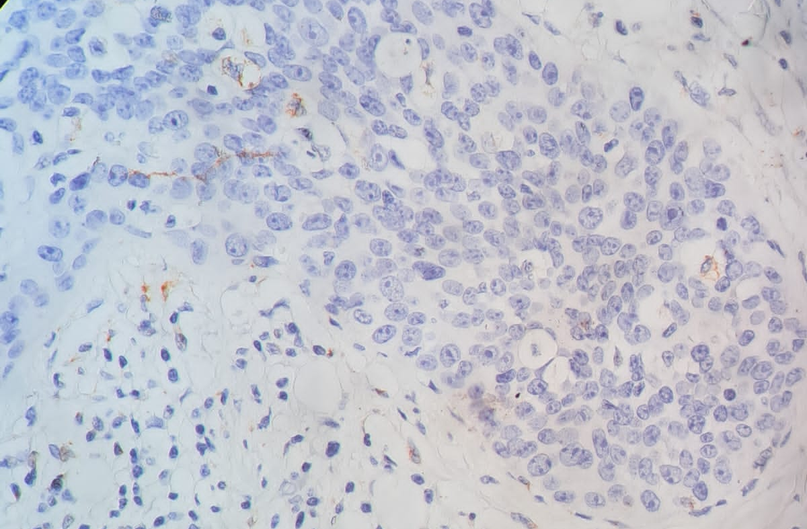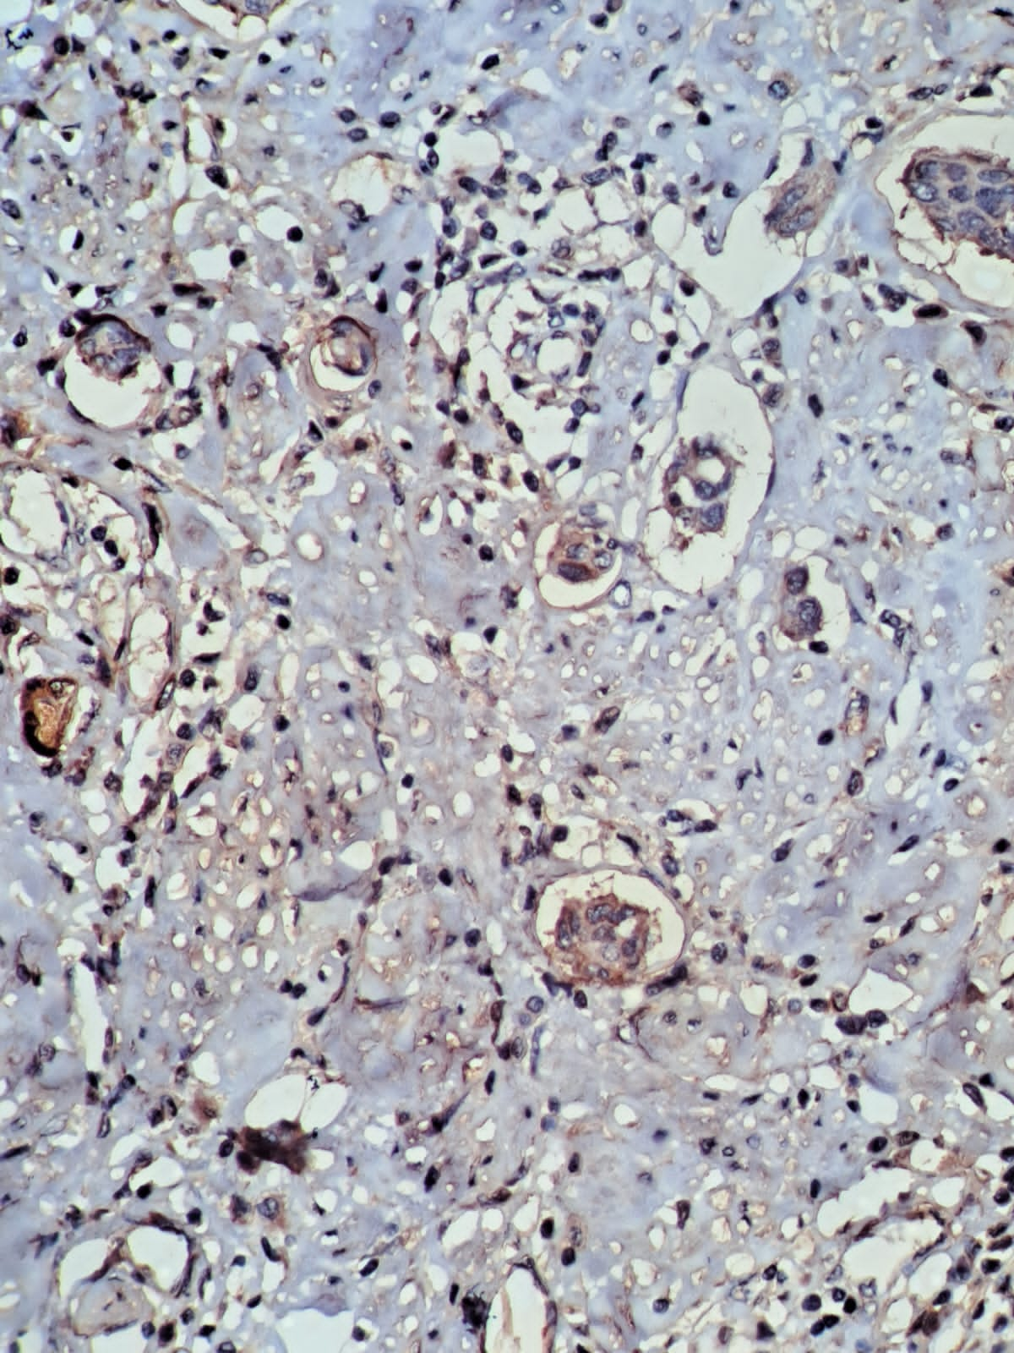
B
A

- Conclusions
The MMP-9 expression was significantly increased risk of lymphovascular invasion in cervical carcinoma These findings indicate that MMP-9 can be considered as a prognostic marker in cervical carcinoma. These findings suggest that high MMP-9 expression contributes to more invasive biological behavior in cervical carcinoma, which induce lymphovascular invasion then could continue to cause metastatic process.

Conflict of Interest
The authors declare that the research was conducted in the absence of any commercial or financial relationships that could be construed as a potential conflict of interest.

Autor Contributions
Ni Wayan Armerinayanti: Conceptualization, Methodology, Writing – Original Draft, Visualization, Supervision, Project Administration, Funding Acquisition, Resources.

Acknowledgments
We would like to express our deepest gratitude to all parties who contributed to this study and to BaliMed Denpasar Hospital and the Faculty of Medicine and Health Sciences, Warmadewa University, for facilitating its completion.

References
    - Dirjen Yanmed. “Kanker di Indonesia 2011”. Jakarta: Dirjen Yanmed Departemen Kesehatan RI.
    - Anonim. 2015. “ICO Information Centre on HPV and Cancer (HPV Information Centre)”. Hpv & Centre.
    - Ferlay, J, Shin, H.R., Bray, F., Forman, D., Mathers, C., Parkin, D.M.2010. Estimetes of worldwild burden of cancerin 2008. Int JCancer. 127: 2893-2917.
    - Dirjen Yanmed. “Kanker di Indonesia 2011”. Jakarta: Dirjen Yanmed Departemen Kesehatan RI.
    - Endo, D., Todo, Y., Okamoto, K., Minobe, S., Kato, H., Nishiyama, N. 2015. “Prognosis factors for patients with cervical cancer treated with concurrent chemoradio theraphy: a retrospective in a Japanese cohort”. J Gyneco lOncol. 26 (1):12-18.
    - Haie-Meder, C., Morice, P., Castiglione. 2010. “Carvical cancer: ESMO clinical practice guidlines for diagnosis, tratment and follow up”. Ann Oncol.21: 37-40.
    - Haie-Meder, C., Morice, P., Castiglione.2010. Carvical cancer: ESMO clinical practice guidlines for diagnosis, tratment and follow up. Ann Oncol.21: 37-40.
    - Huang, B., Cai, J., Xu, X., Guo,S.,Wang, Z.2016. “High grade tumor budding stratifies earlystage cervical cancer with recurrence risk”. PLoS One.11(11): e0166311.
    - Kurman, R.J., Ronnett, B.M., Sherman, M.E., Wilkinson, E.J. 2010. “Tumous of the servix, vagina and vulva”. Thirdseries, Fasicle four. American Registry of Pathology in collaboration with the Armed Forces Institute of Pathology Washington, DC.p.431
    - Kumar, V., Abbas, A.K., Aster, J.C. 2015. Neoplasma. In: Robins and Cotrand: Pathologic Basis of Disease9thEd.Elsevier. Philladelphia.p.266-377.
    - Wang, A., Xu, Q., Sha, R, et al. 2020. “MicroRNA-29a inhibits cell Proliferation and Arrest Cell Cycle by Modulating p16 Methylation in Cervical Cancer”. Oncology Letters. Vol 21:1-9
    - Banno, K., Iida, M., Yakonura, M., Kisu, I., et al. 2014. “MicroRNA in Cervical Cancer: OncomiRs and Tumor Supressor miR in Diagnosis and Treatment”. Hindawi The Scientific World Journal. Vol 2014:1-8
    - Yao, T., Lin Z. 2011. “Mir-21 is Involved in Cervical Squamous Cell Tumorigenesis and Regulates CCL20”. Biochimica et Biophysica Acta. Vol 1822 (2012): 248-260
    - Li, X., Yin, Y., Shen, X., Han, X., Sun, L., Lu, C., Wang, X. 2015. “Distribution pattern of lymphnode metastases and it simplication in individualized radiotherapeutic clinical target volume delineation of regional lymphnodes in patients with stage IA to IIA cervical cancer. Radiation Oncology”. Available from:https://rojournal.biomedcentral.com/articles/10.1186/s13014-015-0352-5
    - Sun, T.,Qin,Y.,Zhong,W.L.2016. “Epithelial-mesenchymal transition and its regulation in tumor metastasis. In: Tumor Metastasis”. Available from: http://www.intechopen.com/books/tumor-metastasis.
    - World Health Organization.2014. “Comprehensive Cervical Cancer Control, 2nd edition, A Guideto Essential Practice”. Availlable from:https://www.ncbi.nlm.nih.gov/books/NBK269619/.
    - Hanafi, A.M.R, Oktaviyanti, I.K., Istiana, I. 2015. “Hubungan Reaksi Limfosit dengan Derajat Keganasan Kanker Serviks di Rsud Ulin Banjarmasin Periode Januari-Desember 2013”. Berkala Kedokteran, 11(1):41-49. DOI: http://dx.doi.org/10.20527/jbk.v11i1.184.
    - Loffek, S., Schilling, O., Franzke, C-W. 2011. “Biological role of matrix metalloproteinases: a critical balance”. Eur Respir J, 38: 191–208.
    - Sriwidyani, N., Alit-artha, I.G., Mantik-Astawa, I.N., Tjakra-Wibawa, I.B. 2016. “Tumor budding in breast carcinoma: relation to E-Cadherin, MMP-9 expression, and metastasis risk”. Bali Medical Journal (Bali Med J) 2016, Volume 5, Number 3: 497-501
    - “Oktaviani, B.D., Sriwidyani, N.P., Sumadi, I.W.J. 2018. Karakteristik Klinikopatologi Penderita Kanker Serviks Uteri Berdasarkan Data Di Laboratorium Patologi Anatomi RSUP Sanglah Denpasar Tahun 2011-2015”. E-Jurnal Medika Udayana. 7(8):1-6. Tersedia di: https://ojs.unud.ac.id/index.php/eum/article/view/41629. Akses: 05 Januari 2022.
    - Armerinayanti, N. W., Bakta, I. M., Alit Artha, I. G., Wahyuniari, I. A. I., & Widodo, S. 2023. “Overexpression of MicroRNA 21 in Cervical Carcinoma with Lymph Node Metastasis”. Biomedical and Pharmacology Journal, 16(1), 479–485. https://doi.org/10.13005/bpj/2628

