Statistic Data
Tests of Normality^{b}
 | Konsentrasi | Kolmogorov-Smirnovª |  |  | Shapiro-Wilk
 | Konsentrasi | Statistic | df | Sig. | Statistic | df | Sig.
Viabilitas Sel | Konsentrasi 5% | .293 | 4 | . | .853 | 4 | .236
Viabilitas Sel | Konsentrasi 10% | .171 | 4 | . | .994 | 4 | .976
Viabilitas Sel | Konsentrasi 15% | .283 | 4 | . | .863 | 4 | .272
Viabilitas Sel | Konsentrasi 20% | .151 | 4 | . | .993 | 4 | .972
Viabilitas Sel | Konsentrasi 25% | .347 | 4 | . | .869 | 4 | .292
a. Lilliefors Significance Correction
b. Viabilitas Sel is constant when Konsentrasi = Kontrol Sel. It has been omitted.

Test of Homogeneity of Varianceª
 |  | Levene Statistic | df1 | df2 | Sig.
Viabilitas Sel | Based on Mean | 1.842 | 4 | 15 | .173
Viabilitas Sel | Based on Median | 1.490 | 4 | 15 | .255
Viabilitas Sel | Based on Median and with adjusted df | 1.490 | 4 | 8.739 | .286
Viabilitas Sel | Based on trimmed mean | 1.780 | 4 | 15 | .185
a. Viabilitas Sel is constant when Konsentrasi = Kontrol Sel. It has been omitted.

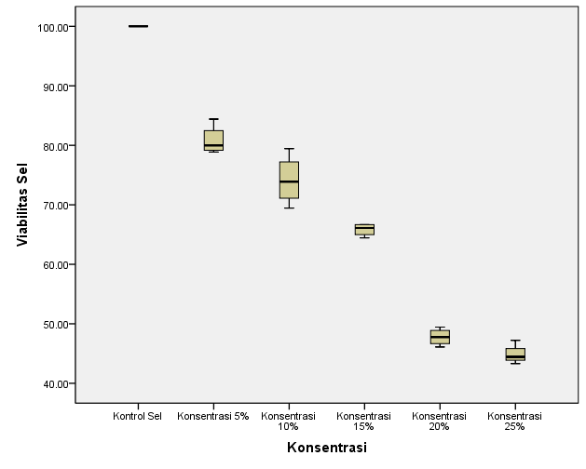

Descriptives
Viabilitas Sel
 | N | Mean | Std. Deviation | Std. Error | 95% Confidence Interval for Mean |  | Minimum | Maximum
 |  |  |  |  | Lower Bound | Upper Bound | Minimum | Maximum
Kontrol Sel | 4 | 100.0000 | .00000 | .00000 | 100.0000 | 100.0000 | 100.00 | 100.00
Konsentrasi 5% | 4 | 80.8175 | 2.48712 | 1.24356 | 76.8599 | 84.7751 | 78.88 | 84.40
Konsentrasi 10% | 4 | 74.1625 | 4.19502 | 2.09751 | 67.4873 | 80.8377 | 69.44 | 79.44
Konsentrasi 15% | 4 | 65.8350 | 1.06710 | .53355 | 64.1370 | 67.5330 | 64.44 | 66.67
Konsentrasi 20% | 4 | 47.7750 | 1.43300 | .71650 | 45.4948 | 50.0552 | 46.11 | 49.44
Konsentrasi 25% | 4 | 44.8500 | 1.66889 | .83445 | 42.1944 | 47.5056 | 43.30 | 47.22
Total | 24 | 68.9067 | 19.53064 | 3.98668 | 60.6596 | 77.1537 | 43.30 | 100.00

ANOVA
Viabilitas Sel
 | Sum of Squares | df | Mean Square | F | Sig.
Between Groups | 8683.971 | 5 | 1736.794 | 350.145 | .000
Within Groups | 89.284 | 18 | 4.960
Total | 8773.255 | 23

Multiple Comparisons
Viabilitas Sel
LSD
(I) Konsentrasi | (J) Konsentrasi | Mean Difference (I-J) | Std. Error | Sig. | 95% Confidence Interval
 |  |  |  |  | Lower Bound | Upper Bound
Kontrol Sel | Konsentrasi 5% | 19.18250* | 1.57484 | .000 | 15.8739 | 22.4911
Kontrol Sel | Konsentrasi 10% | 25.83750* | 1.57484 | .000 | 22.5289 | 29.1461
Kontrol Sel | Konsentrasi 15% | 34.16500* | 1.57484 | .000 | 30.8564 | 37.4736
Kontrol Sel | Konsentrasi 20% | 52.22500* | 1.57484 | .000 | 48.9164 | 55.5336
Kontrol Sel | Konsentrasi 25% | 55.15000* | 1.57484 | .000 | 51.8414 | 58.4586
Konsentrasi 5% | Kontrol Sel | -19.18250* | 1.57484 | .000 | -22.4911 | -15.8739
Konsentrasi 5% | Konsentrasi 10% | 6.65500* | 1.57484 | .001 | 3.3464 | 9.9636
Konsentrasi 5% | Konsentrasi 15% | 14.98250* | 1.57484 | .000 | 11.6739 | 18.2911
Konsentrasi 5% | Konsentrasi 20% | 33.04250* | 1.57484 | .000 | 29.7339 | 36.3511
Konsentrasi 5% | Konsentrasi 25% | 35.96750* | 1.57484 | .000 | 32.6589 | 39.2761
Konsentrasi 10% | Kontrol Sel | -25.83750* | 1.57484 | .000 | -29.1461 | -22.5289
Konsentrasi 10% | Konsentrasi 5% | -6.65500* | 1.57484 | .001 | -9.9636 | -3.3464
Konsentrasi 10% | Konsentrasi 15% | 8.32750* | 1.57484 | .000 | 5.0189 | 11.6361
Konsentrasi 10% | Konsentrasi 20% | 26.38750* | 1.57484 | .000 | 23.0789 | 29.6961
Konsentrasi 10% | Konsentrasi 25% | 29.31250* | 1.57484 | .000 | 26.0039 | 32.6211
Konsentrasi 15% | Kontrol Sel | -34.16500* | 1.57484 | .000 | -37.4736 | -30.8564
Konsentrasi 15% | Konsentrasi 5% | -14.98250* | 1.57484 | .000 | -18.2911 | -11.6739
Konsentrasi 15% | Konsentrasi 10% | -8.32750* | 1.57484 | .000 | -11.6361 | -5.0189
Konsentrasi 15% | Konsentrasi 20% | 18.06000* | 1.57484 | .000 | 14.7514 | 21.3686
Konsentrasi 15% | Konsentrasi 25% | 20.98500* | 1.57484 | .000 | 17.6764 | 24.2936
Konsentrasi 20% | Kontrol Sel | -52.22500* | 1.57484 | .000 | -55.5336 | -48.9164
Konsentrasi 20% | Konsentrasi 5% | -33.04250* | 1.57484 | .000 | -36.3511 | -29.7339
Konsentrasi 20% | Konsentrasi 10% | -26.38750* | 1.57484 | .000 | -29.6961 | -23.0789
Konsentrasi 20% | Konsentrasi 15% | -18.06000* | 1.57484 | .000 | -21.3686 | -14.7514
Konsentrasi 20% | Konsentrasi 25% | 2.92500 | 1.57484 | .080 | -.3836 | 6.2336
Konsentrasi 25% | Kontrol Sel | -55.15000* | 1.57484 | .000 | -58.4586 | -51.8414
Konsentrasi 25% | Konsentrasi 5% | -35.96750* | 1.57484 | .000 | -39.2761 | -32.6589
Konsentrasi 25% | Konsentrasi 10% | -29.31250* | 1.57484 | .000 | -32.6211 | -26.0039
Konsentrasi 25% | Konsentrasi 15% | -20.98500* | 1.57484 | .000 | -24.2936 | -17.6764
Konsentrasi 25% | Konsentrasi 20% | -2.92500 | 1.57484 | .080 | -6.2336 | .3836
*. The mean difference is significant at the 0.05 level.

