

JURNAL SKALA HUSADA: THE JOURNAL OF HEALTH
Available online at: https://ejournal.poltekkes-denpasar.ac.id/index.php/JSH
Vol. x No. x Bulan 202x
P-ISSN 1693-931X I e-ISSN 2580-3700 Halaman: x-xx

In Silico Study of Gingerol and Shogaol from Red Ginger Rhizome (Zingiber Officinale var. rubrum) as Anti-Inflamatory

Ni Made Ayu Sukma Dinda¹, Ni Wayan Rika Kumara Dewi^{2*}, Ni Made Suastini³

^{1,2,3} Institute of Technology and Health Bintang Persada

Posted : Reviewed : Received: xxxxxxxx

ABSTRACT

Inflammation occurs when the enzyme phospholipase A2 (PLA2) releases arachidonic acid from cell membranes, leading to the production of pro-inflammatory mediators. Gingerol and shogaol are bioactive compounds with anti-inflammatory properties found in red ginger (Zingiber Officinale var. rubrum). This research aims to investigate the potential anti-inflammatory activity of gingerol and shogaol against osteoarthritis using in silico methods. The in silico tests utilized Hyperchem 8, Chimera 1.10.1, and molecular docking was performed using AutoDock Tools, supplemented with Autogrid and Autodock 4. The results of molecular docking showed hydrogen bonds and binding energy. The binding energy values for 10-gingerol were -9.01 kcal/mol, 10-shogaol -8.85 kcal/mol, 8-shogaol -8.72 kcal/mol, and 6-gingerol -8.07 kcal/mol. The results indicate that gingerol and shogaol compounds have higher binding energies compared to the target protein Phospholipase A2 (Sodium Diclofenac) at -7.57 kcal/mol. This suggests that gingerol and shogaol compounds from red ginger rhizome (Zingiber Officinale var. rubrum) have potential as anti-inflammatory agents.

Keywords: gingerol; shogaol; anti-inflammatory; phospoliphase A2; in silico

ABSTRAK
Inflamasi atau peradangan terjadi akibat enzim phospoliphase A2 (PLA2) yang melepaskan asam arakidonat dari membran sel, sehingga menghasilkan mediator proinflamasi. Gingerol dan shogaol merupakan senyawa bioaktif yang memiliki kandungan antiinflamasi pada tanaman jahe merah (Zingiber Officinale var. rubrum). Penelitian ini bertujuan untuk mengetahui potensi aktivitas dari gingerol dan shogaol sebagai antiinflamasi terhadap penyakit osteoartritis secara in silico. Uji in silico menggunakan program Hyperchem 8, Chimera 1.10.1 dan pengujian molecular docking menggunakan program AutoDock Tools, dilengkapai dengan program (Autogrid dan Autodock 4). Hasil pengujian molecular docking adalah ikatan hidrogen dan energi ikatan. Nilai energi ikatan pada senyawa 10-gingerol sebesar -9,01 kkal/mol, 10-shogaol sebesar -8,85 kkal/mol, 8-shogaol sebesar -8,72 kkal/mol dan 6-gingerol sebesar -8,07 kkal/mol, Hasil menyatakan bahwa senyawa gingerol dan shogaol memiliki energi ikatan yang lebih besar dibandingkan dengan protein target Phospholiphase A2 (Natrium Diclofenac) sebesar -7,57 kkal/mol. Hal ini menunjukan bahwa senyawa gingerol dan shogaol dari Rimpang Jahe Merah (Zingiber Officinale var. rubrum) berpotensi sebagai antiinflamasi.

Kata kunci: gingerol; shogaol; antiinflamasi; phospoliphase A2; in silio

- Corresponding Author:
Ni Wayan Rika Kumara Dewi
Institute of Technology and Health Bintang Persada
E-mail: rikakumara1987@gmail.com
Copyright © 202x, Jurnal Skala Husada: The Journal of Health
INTRODUCTION

Red ginger is a prolific plant native to South Asia and is widely distributed throughout the world. In Asia, particularly in Indonesia, red ginger is often used as an alternative medicine and raw material for herbal drinks (1). Red ginger offers greater benefits compared to other types of ginger because its rhizomes contain essential oil reserves, including limonene, camphene, zingiberene, gingerol, and shogaol. Gingerol in red ginger causes the characteristic hot taste and is very effective as an anti-inflammatory agent for the body (2). The primary components responsible for the spicy flavor in red ginger are gingerol and shogaol. The primary compounds within the red ginger rhizome are gingerol compounds, such as 6-gingerol, 8-gingerol, and 10-gingerol (3). Inflammation is a normal protective response to tissue injury caused by physical trauma, damaging chemicals, or microbiological substances. Inflammation is the body's attempt to inactivate or destroy invading organisms, remove irritants, and set the stage for tissue repair (4). Ginger spice and its various phytoconstituents have the potential to reduce inflammation. In traditional Asian medicine preparations, ginger rhizomes have been used to treat mild forms of rheumatoid arthritis and osteoarthritis, aligning with these effects. Phenylpropanoids from ginger rhizomes (gingerol, shogaol) have been found to target the enzyme phospholipase A2, inhibiting the secretion of IL-1beta and prostanoids, thus potentially disrupting arachidonate-phospholipid remodeling (5). One medicinal plant known to have anti-inflammatory effects is red ginger (Zingiber officinale var. rubrum), which contains active compounds such as gingerol and shogaol that play a role in inhibiting the inflammatory process. Gingerol, zingerone, and shogaol are three forms of red ginger derived from bitter, spicy, and aromatic oleoresin. It also contains anti-inflammatory oleoresin, potent antioxidants, and analgesics, which help alleviate joint pain and muscle tension by preventing the formation of prostaglandins. Based on this, the potential of gingerol content can be developed as a new anti-inflammatory drug (6).
Molecular docking studies can be used to predict the bioactivity of a compound before conducting laboratory experiments. The advantages of this method include reducing the use of experimental animals, equipment, materials, and costs, as well as visualizing the ligand's mechanism of action on its target and optimizing the ligand's compound structure (7). The program used for docking ligands with their target proteins is AutoDock Tools 1.5.7. AutoDock 4 consists of two main programs: AutoDock4 and AutoGrid. Based on the literature review regarding molecular docking from previous research, this study will conduct molecular docking to determine the potential of gingerol and shogaol from red ginger rhizome (Zingiber Officinale var. rubrum) as anti-inflammatory agents for osteoarthritis by inhibiting the phospholipase A2 (PLA2) enzyme by in silico.

MATERIALS AND METHODS
MATERIALS
The 3D structures of the bioactive compounds gingerol and shogaol can be downloaded from website https://pubchem.ncbi.nlm.nih.gov/. The structure of the target protein phospholipase A2 (PDB ID: 2B17) can be downloaded from the Protein Data Bank (PDB) website at http://www.rcsb.org/pdb/home/home.do. The Materials and Methods section includes the following components: research design, research procedures, sampling method, and data analysis method.
METHODS
- Optimization of the 3D Structures of Gingerol and Shogaol Compounds
The 3D structures of the gingerol and shogaol compounds were optimized using the Hyperchem 8 program. The optimization was performed using the semi-empirical AM1 (Austin Model 1) computational method, and single point calculations and geometry optimization were carried out.
- Preparation of the 3D Structure of the Target Protein Phospholipase A
Protein preparation was performed using the Chimera 1.10.1 program by separating the 3D structure of the Phospholipase A2 protein from its native ligand.
- Validation of the Molecular Docking Method
The validation of the molecular docking method was performed using Autodock Tools (Autodock 4 and Autogrid) by re-docking the native ligand to the phospholipase A2 protein from which its native ligand had been removed. The validation parameter for the molecular docking method is the Root Mean Square Deviation (RMSD) value. The docking method is considered valid if the RMSD value is ≤3 Å, which means that the docking parameters used are valid and can be used subsequently for docking the test compounds (8)
- Docking of Gingerol and Shogaol to the Phospholipase A2 Protein
The optimized gingerol and shogaol compounds were subsequently docked to the phospholipase A2 protein, from which its native ligand had been removed, using the Autodock Tools application with the same docking procedure as during the method validation using the native ligand. The analysis results reveal the binding conformation of the compounds to the protein, along with their binding energy values and the hydrogen bonds formed.
- Data Analysis
The results from the molecular docking process are the binding energy and the hydrogen bonds formed. Binding energy is used to indicate the strength of the bond between the compound and the protein. The lower the binding energy value, the stronger and more stable the bond formed. Meanwhile, the types of hydrogen bonds are used to analyze the interaction mechanisms that are formed.
RESULTS AND DISCUSSIONS
- Optimization of the 3D Structures of Gingerol and Shogaol Compounds
The downloaded 3D structures of the gingerol and shogaol compounds were optimized using the Hyperchem 8 program with the semi-empirical AM1 computational method. The optimization steps included single-point calculations and geometry optimizations to obtain the most stable structures of the gingerol and shogaol compounds. In the semi-empirical method, a simplification of the two-electron integrals of the Hamiltonian is performed. The success of the compound optimization is indicated by the total energy resulting from geometry optimization being lower than that from the single-point calculation. The optimization results for the gingerol and shogaol compounds are shown in Figure 1.
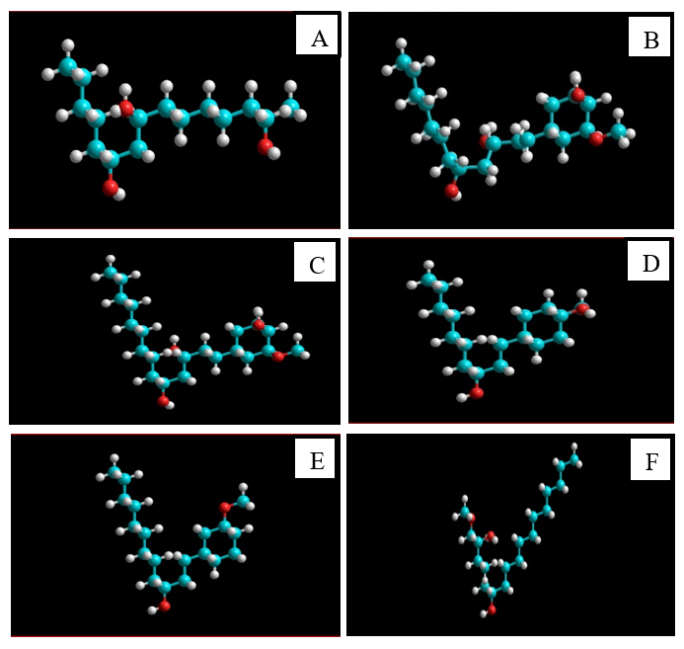
Figure 1. Optimization Results of the 3D Structures of Gingerol and Shogaol Compounds

The total energy values from the single point calculations and geometry optimizations obtained for the gingerol and shogaol compounds were as follows: for 6-gingerol, -4682.1934 kcal/mol and -5180.0640 kcal/mol, respectively; for 8-gingerol, -5651.7561
kcal/mol and -5746.5419 kcal/mol; for 10-gingerol, -6213.7397 kcal/mol and -6310.4090 kcal/mol; for 6-shogaol, -4979.9553 kcal/mol and -5084.9439 kcal/mol; for 8-shogaol, -5551.5017 kcal/mol and -5648.3059 kcal/mol; and 10-shogaol, -6113.4146 kcal/mol and -6208.5909 kcal/mol. Based on these results, the optimized structures of the gingerol and shogaol compounds were obtained.
- Preparation of Phospholipase A2 Protein
The Phospholipase A2 (PLA2) protein was prepared by separating the target protein from its native ligand using the Chimera 1.10.1 program, resulting in a protein structure without the native ligand and a separate native ligand structure, as shown in Figure 2. The separation of the protein from its native ligand aims to provide a binding pocket for the test compounds to interact with the PLA2 protein. In the PLA2 target protein, there is only 1 chain A that will be used for the docking process, and the native ligand present in chain A is the native ligand (DIF).
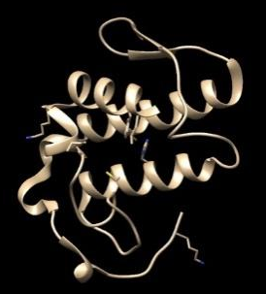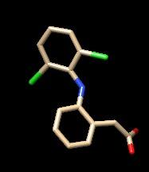
Figure 2. Structure of PLA2 Protein without Ligand (a) and Native Ligand (b)

c. Validation of the Molecular Docking Method
The validation of the molecular docking method was performed using the AutoDockTools 1.5.7 program with the redocking method (re-docking) of the native ligand of the PLA2 protein with the prepared macromolecule. The parameter used was the Root Mean Square Deviation (RMSD). The results obtained in this process are the grid box parameters and the RMSD value (9).
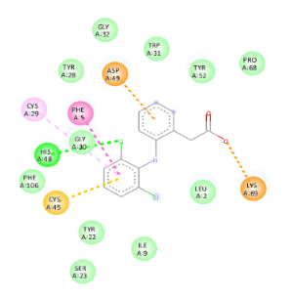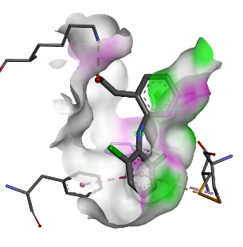
Figure 3. Visualization of the 2D (a) and 3D (b) interactions
of the PLA2 protein with its native ligand
- Docking of Gingerol and Shogaol to the Phospholipase A2 Protein
Docking of the optimized gingerol and shogaol compounds to the PLA2 protein was performed using the Autodock Tools application with the same procedures and coordinates as in the validated method. The docking results of gingerol and shogaol compounds to the PLA2 protein yielded 10 binding conformations, from which one conformation with the lowest binding energy, indicating the most stable, was selected. The docking results between gingerol and shogaol compounds and the native ligand with the PLA2 protein showed that the binding energies between the gingerol and shogaol compounds and the PLA2 protein were negative. In the PLA2 protein, gingerol and shogaol compounds have higher binding energies compared to the native ligand. This suggests that the potential of gingerol and shogaol compounds to bind to the active site of PLA2 is weaker than that of its native ligand, but they still possess the ability to bind. The binding energy values of the native ligand, gingerol, and shogaol compounds to the PLA2 target protein were -10.45 kcal/mol and -8.24 kcal/mol, respectively, as shown in Table 1. Based on these results, gingerol and shogaol compounds can interact with the PLA2 protein by forming hydrogen bonds at the amino acid MET801, which is the same hydrogen bond formed in the docking between the native ligand and the PLA2 protein. This indicates that the active site where the native ligand and gingerol and shogaol compounds bind on the PLA2 protein is the same, thus resulting in a similar affinity to the native ligand in inhibiting the protein.
Table 1. Docking Results of Gingerol and Shogaol Compounds with the Native Ligand on PLA2 Protein

Protein  Target | Ligan | Energi Ikatan  (Kkal/mol) | Ikatan  Hidrogen
PLA2  (2B17) | Native ligand | -7,57 | HIS48
PLA2  (2B17) | 6-gingerol | -8,07 | GLY30  TYR22
PLA2  (2B17) | 8-gingerol | -6,09 | HIS48  LYS69  TYR22
PLA2  (2B17) | 10-gingerol | -9,01 | CYS29  HIS48  CYS45  TYR22
PLA2  (2B17) | 6-shogaol | -7,65 | CYS45
PLA2  (2B17) | 8-shogaol | -8,72 | LYS69  CYS45  HIS48
PLA2  (2B17) | 10-shogaol | -8,85 | CYS45

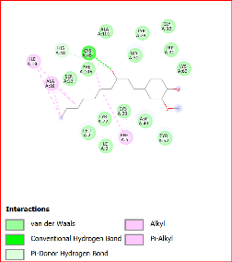 | 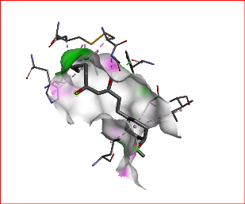
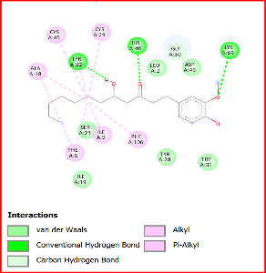 | 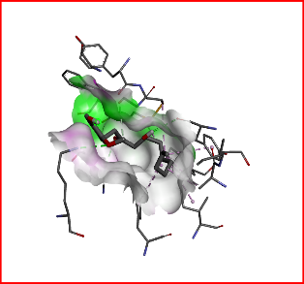
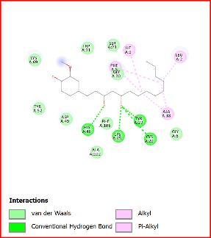 | 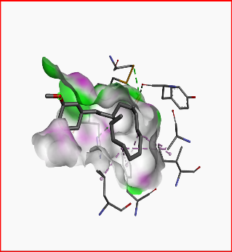
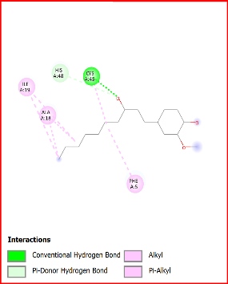 | 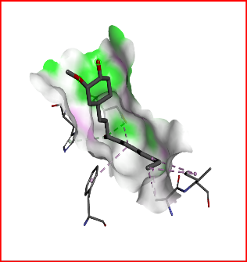
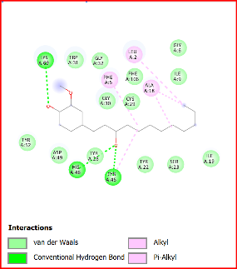 | 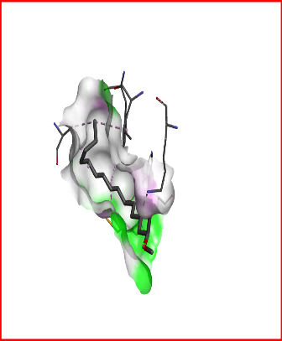

Figure 4. Visualization of the 2D and 3D Interaction Results of Docking Gingerol and Shogaol Compounds to the PLA2 Target Protein.

CONCLUSIONS
Based on the research results, it can be concluded that the affinity of several derivatives of gingerol and shogaol compounds have higher binding energy values compared to its native ligand, which has a value of -7.5 kcal/mol on the target protein phospholipase A2 enzyme. Gingerol and shogaol compounds inhibit the phospholipase A2 (PLA2) enzyme, acting as anti-inflammatory agents.

REFERENCES

1. Priscinya Christiana Debora A, Ayu Pratama A, Ambarati T, Granadha S, Nuriah S, Ilmu Kesehatan F, et al. Review Artikel: Efektivitas Senyawa Antiinflamasi Dan Antibakteri Pada Rimpang Jahe (Zingiber officinale R.). 2022;19–29.
2. Masniah M, Rezi J, Faisal AP. Isolasi Senyawa Aktif Dan Uji Aktivitas Ekstrak Jahe Merah (Zingiber Officinale) Sebagai Imunomodulator. J Ris Kefarmasian Indones. 2021;3(2):77–91.
3. Mao QQ, Xu XY, Cao SY, Gan RY, Corke H, Beta T, et al. Bioactive compounds and bioactivities of ginger (zingiber officinale roscoe). Foods. 2019;8(6):1–21.
4. Garakia CSH, Sangi M, Koleangan HSJ. Uji Aktivitas Antiinflamasi Ekstrak Etanol Tanaman Patah Tulang (Euphorbia tirucalli L.). J MIPA. 2020;9(2):60.
5. Matin M, Joshi T, Wang D, Tzvetkov NT, Matin F Bin, Wierzbicka A, et al. Effects of Ginger (Zingiber officinale) on the Hallmarks of Aging. Biomolecules. 2024;14(8):1–37.
6. Akmal Syihabuddin, Taufik Muhammad Fakih, Dwi Syah Fitra Ramadhan. Pengembangan Obat Baru dari Senyawa Curcumin, Genistein, Lactacystin, Phloretin, Quercetin sebagai Inhibitor RNA Polimerase MTB dengan Menggunakan Metode In Silico. Bandung Conf Ser Pharm. 2022;2(2):1062–70.
7. Pharmacia J, Waluya M, Pharmacia J, Waluya M, No V, Zulfa T, et al. Studi Molecular Docking Senyawa Kimia dari Herba Putri Malu ( Mimosa pudica ) Terhadap Inhibisi Enzim A-Glukosidase Sebagai Antidiabetes Melitus A Study Of The Molecular Docking of Chemical Compounds From The Mimosa Herb ( Mimosa pudica ) on The α -Glucos. 2024;3(4).
8. Muttaqin FZ. Studi Molecular Docking, Molecular Dynamic, Dan Prediksi Toksisitas Senyawa Turunan Alkaloid Naftiridin Sebagai Inhibitor Protein Kasein Kinase 2-Α Pada Kanker Leukemia. Pharmacoscript. 2019;2(1):49–64.
9. Vitadella V, Bulan CP, Sinurphospat JAN, Latief M, Yusnaidar Y, Tarigan IL. Studi In Silico Senyawa Bioaktif Daun Miana (Coleus scutellariodes (L). Benth) sebagai Inhibitor Enzim Asetikolineterase (Ache) pada Alzheimer. J Sains dan Kesehat. 2024;6(2):282–91.

